**Digital Gateway**

For Digital Gateway, we don’t have the config files and stop/start operations will be done through the normal commands.

Stop – mqsistop broker-name

Start – mqsistart broker-name

**WU and Walmart Gateway**

For WU and Walmart Gateway, we do have the config files andstop/start operations will be done through the scripts that are mentioned below.

cd /apps/wubsg/config/mqsipolicy

Stop -> ./ACE-BrokerStop.sh

Start -> ./ACE-BrokerStart.sh

**NRT servers 10.47.17.149 & 10.47.17.150**

cd /apps/wubsg/config/mqsipolicy

Stop -> ./ACE-BrokerStop_NRT.sh

Start -> ./ACE-BrokerStart_NRT.sh

**Stopping the broker:**

After stopping the broker check the status by using the below command

mqsilist broker-name

If at all the broker is not getting stopped then kill the process.

kill -9 process-id

**Starting the broker:**

After starting the broker verify the path /apps/wubsg/config and make sure no config files are present

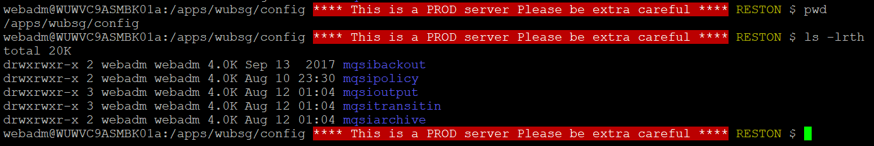

And the config files should be updated with the latest timestamp at path

/apps/wubsg/config/mqsiarchive

Ex:



Go to the path /apps/wubsg/config/mqsioutput and verify the files mentioned below are updated with the latest time stamp and they must have the successful entries.

If the number of config files are 4 then the successful entries having the latest timestamp in the following files must also be the same.

cd /apps/wubsg/config/mqsioutput

tail –f GlobalCache_Success.xml  
tail –f AIS_Status.xml

GlobalCache_Success.xml

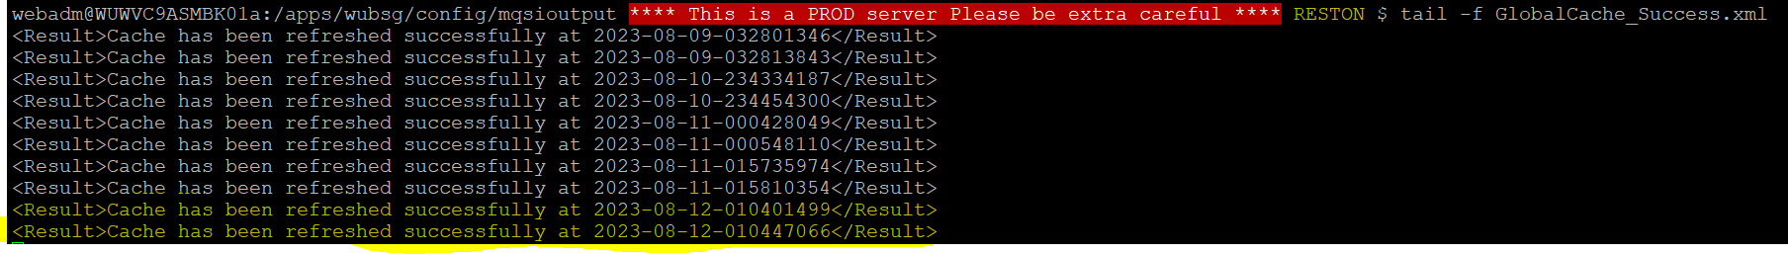

AIS_Status.xml 

* Execute the below command and make sure the Number of containers matching and Total known containers should be matching, if not wait for some more time till the broker is fully started.

mqsicacheadmin broker-name -c showPlacement

Ex:- mqsicacheadmin ACENDP0 -c showPlacement

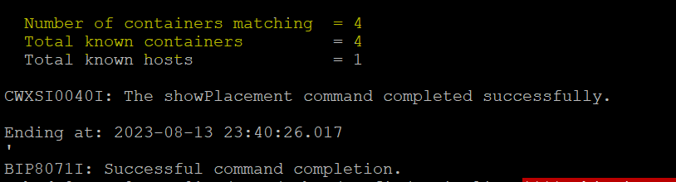

* Execute the below command and make sure the Total catalog service domain count must in MB’s not in KBs, If it’s in KB’s then the config files are not loaded properly. So, reload the config files and check again.

mqsicacheadmin brokername -c showMapSizes

Ex: mqsicacheadmin ACENDP0 -c showMapSizes



* Once all the above actions and validations are completed then start the DASCloudOkta flow and NRT_Notification_Service

**Note**: - The DASCloudOkta flow must be started on all the NRT and non-NRT servers where as NRT_Notification_Service must be started only on the NRT servers (10.47.17.149 & 10.47.17.150)

**DASCloudOkta:**

mqsistartmsgflow broker-name -e BIS_EG -k BIS_Quotation_APP -m DASCloudOkta

Ex: mqsistartmsgflow ACENDP0 -e BIS_EG -k BIS_Quotation_APP -m DASCloudOkta

**NRT_Notification_Service:**

mqsistartmsgflow broker-name -e NRT_EG -k NRT_Notification_Service

EX: mqsistartmsgflow ACENDP0 -e NRT_EG -k NRT_Notification_Service

**Ace – Toolkit**

**Note**: The deployment in Ace is same as IIB

Ace toolkit Icon in the taskbar



Toolkit Interface:

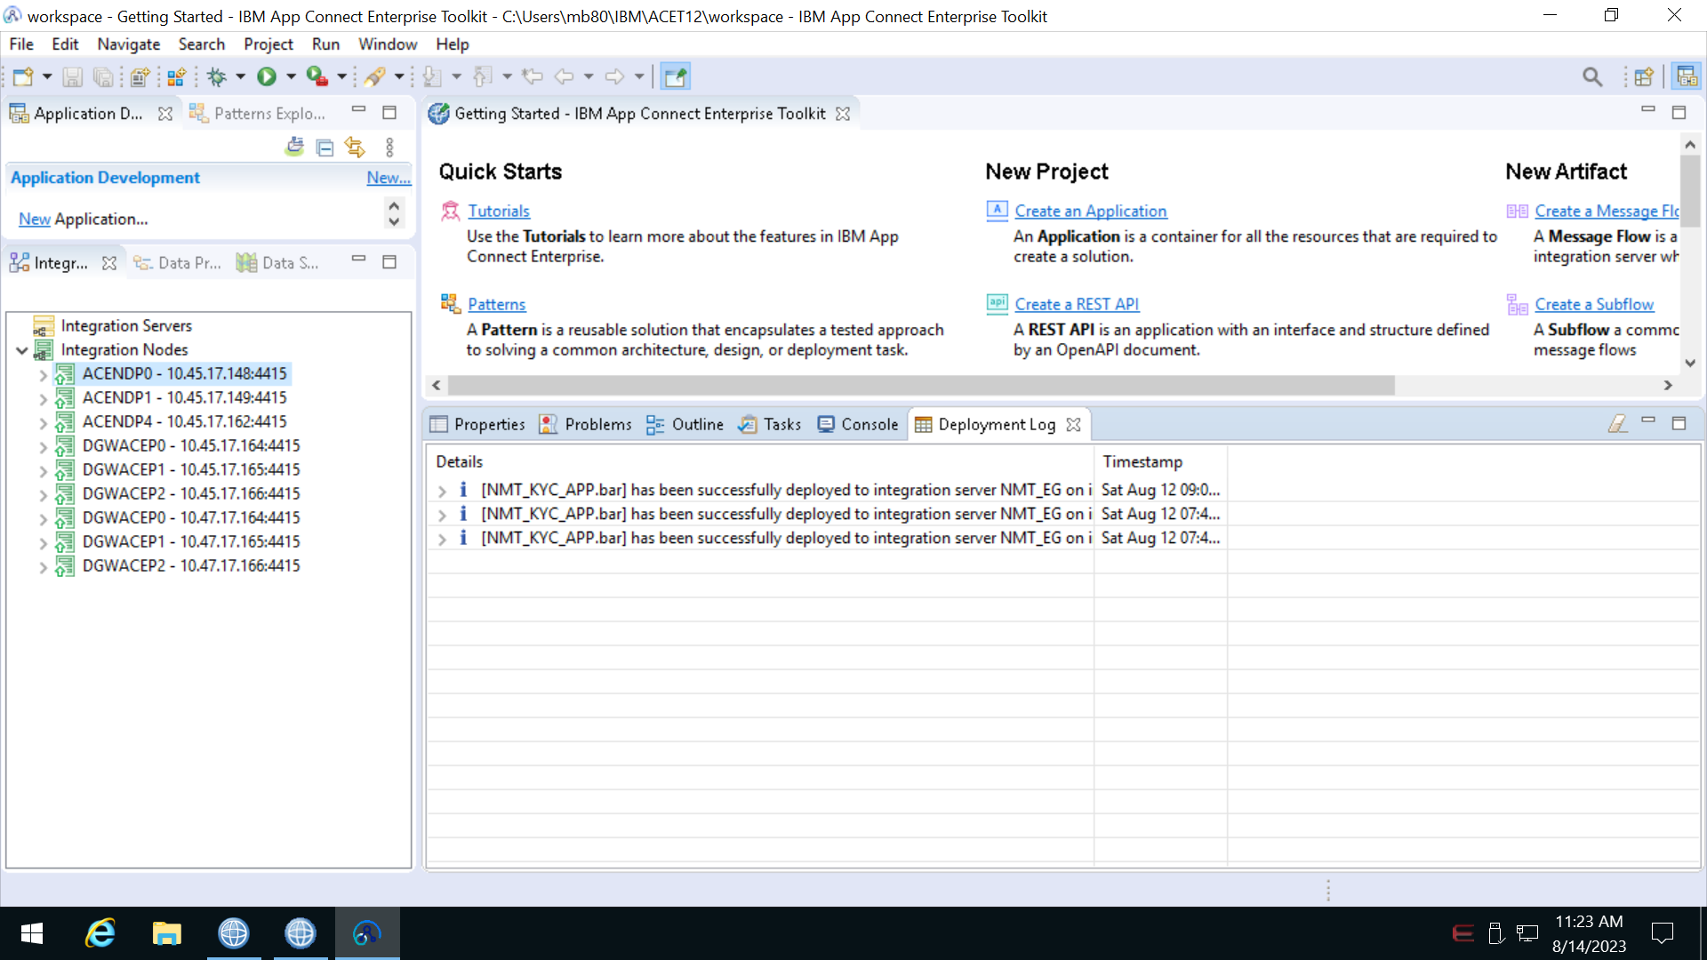

Integration Nodes

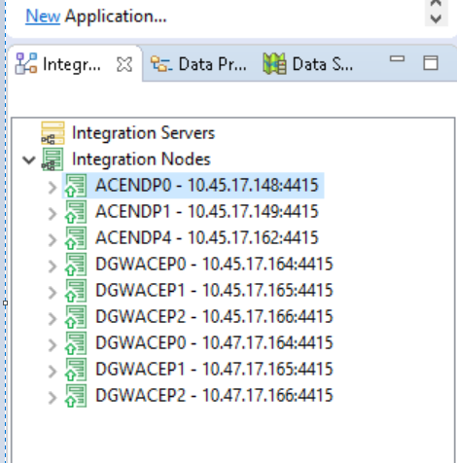

**Bar file deployment**:

For one bar file we can directly deploy to the particular Execution group

For two or more bar files in Application Development section we can create a folder and copy all the bar files from which we can directly deploy to the specific execution group all together in one go.

